UI Design and Prototyping Report Template

# Introduction

* A fitness blog is an easily accessible online source of motivation and guidance for everything fitness related.
* So far the features will include different pages for home, workouts, challenges, blog and about.
* The logo will be used to navigate back to the homepage.
* Content will be divided into meaningful sections and images will be used to increase the appeal of the website.
* This will help me use the bootstrap knowledge I will acquire throughout this course. So far, I can see myself using responsive design, bootstrap grids, cards, tables, media objects, alerts to make this website.

# User Interface Design and Prototype

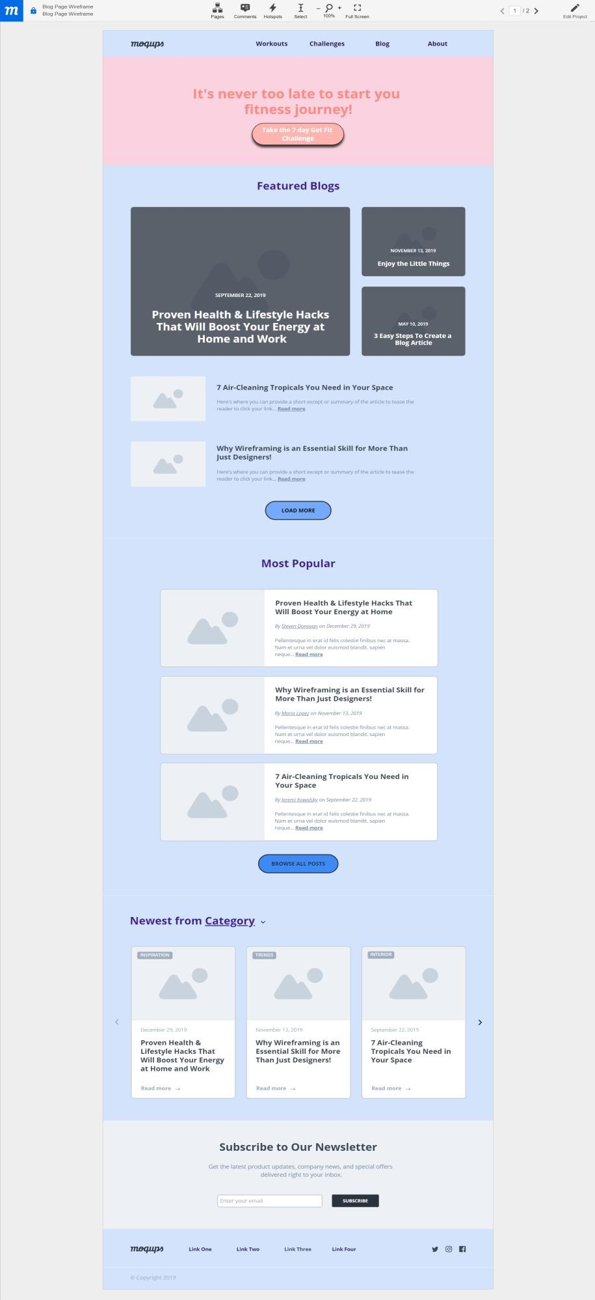

*Figure 1 Homepage*

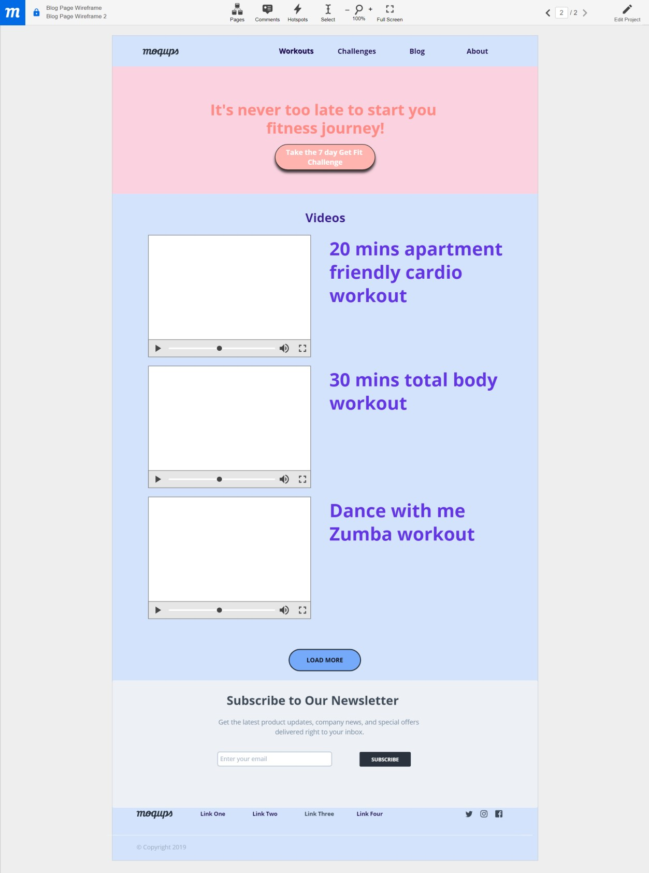

*Figure 2 Workouts page*

# Navigation Structure

* Navigation will be facilitated by navbar, buttons, link,etc.
* Flow of application:

•

Home

Workouts

Videos

Challenges

day get fit

7

challenge

Youtube

playlist for

challenge

28

day fitness

challenge

Youtube

playlist for

challenge

Blog

Links to

different blog

articles

About

Information

about blog

4. References

<https://app.moqups.com/wzvX8LEiGs/edit/page/ae973f342>

<https://www.blogilates.com><https://moqups.com/><https://www.webdesign-inspiration.com/><https://expo.getbootstrap.com/>